去重组件接口文档


http://ICTCLAS.nlpir.org/
@ICTCLAS张华平博士
2012-12

目录
去重组件接口文档 1
目录 2
0. 去重组件简介 3
1．C＋＋接口 4
1.1 RR_Init 4
1.2 RR_Exit; 5
1.3 RR_FileProcess 6
1.4 RR_FindRepeat 7
1.5 RR_Output 9
1.6 RR_SaveData 11
1.7 RR_GetLastErrMsg 12
2 LJDupRemover运行环境 14
3 常见问题（FAQ） 15
Q: LJDupRemover系统初始化老是失败 15
4 作者简介 15

去重组件简介
能够快速准确地判断文件集合或数据库中是否存在相同或相似内容的记录，同时找出所有的重复记录。


访问http://ictclas.nlpir.org/(自然语言处理与信息检索共享平台)，您可以获取LJDupRemover组件的最新版本，并欢迎您关注张华平博士的新浪微博 @ICTCLAS张华平博士 交流。

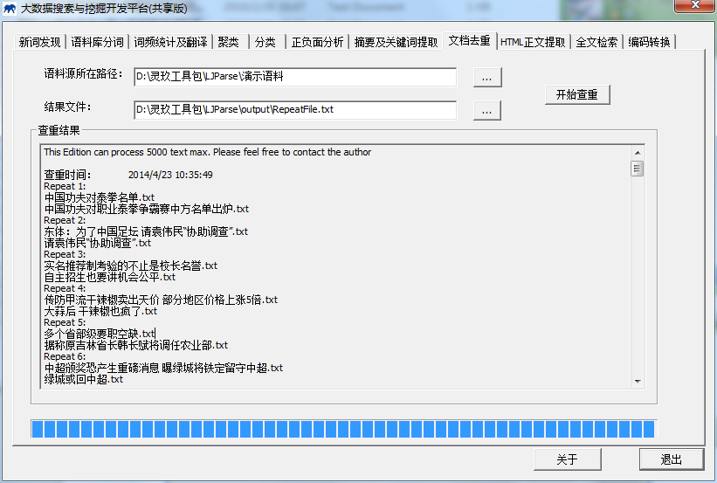
图1：文档去重功能展示

1．C＋＋接口

1.1 RR_Init
Init the analyzer and prepare necessary data for LJDupRemove according the configure file.
bool RR_Init(const char *DataFilePath = "Data.txt", const char *sLicenseCode=0);
Routine | Required Header
RR_Init | <LJDupRemover.h>
Return Value
Return true if init succeed. Otherwise return false.
Parameters
DataFilePath : Initial , load the “Data.txt” file that contain Duplicate removal data.
const char* sLicenceCode: licence coding of input string,
Remarks
The RR_Init function must be invoked before any operation with LJDupRemove. The whole system need call the function only once before starting LJDupRemove. When stopping the system and make no more operation, RR_Exit should be invoked to destroy all working buffer. Any operation will fail if init do not succeed.
RR_Init fails mainly because of two reasons: 1) Required data.txt is incompatible or missing 2) invalid parameters. Moreover, you could learn more from the log file 2014****.log in the current directory.
Example
int _tmain(int argc, _TCHAR* argv[])
{
if (!RR_Init("RR_Data.txt","Data"))
{
printf("%s\r\n", RR_GetLastErrMsg());
printf("去重组件初始化失败，请退出并检查！该联系www.nlpir.org/或者新浪微博@ICTCLAS张华平博士！\n");
return-1;
}

vector<string> fileDir;
string path = "./test/";
string sContent = "";
if(!gfn_bScanFiles(path.c_str(),fileDir))
{
printf("获取文件夹中文件失败......\n");
system("pause");
return -1;
}
string sFilename;
char *pcFindAll = new char[65565];
for (int i = 0; i < fileDir.size();i++)
{
gfn_bReadFile((path + fileDir.at(i)).c_str(), sContent);
sFilename = fileDir.at(i).c_str();
sContent += "\r\n";
if (RR_FileProcess(sContent.c_str(), sFilename.c_str()) == 1)
{
memset(pcFindAll, 0, 65565);
RR_FindRepeat(pcFindAll, true);
}
}

if (pcFindAll != NULL)
{
delete[] pcFindAll;
pcFindAll = NULL;
}

RR_Output("");
RR_SaveData("RR_Data.txt");
RR_Exit();
return 0;
}
Output

1.2 RR_Exit;
Exit the program and free all resources and destroy all working buffer used in LJDupRemover.
void RR_Exit();
Routine | Required Header
RR_Exit | <LJDupRemover.h>
Return Value
none.
Parameters
none
Remarks
The RR_Exit function must be invoked while stopping the system and make no more operation. And call RR_Exit function to restart LJDupRemover.
Example
看上例红色。
Output

1.3 RR_FileProcess
int RR_FileProcess(const char *FileText, const char *FileName);
Routine | Required Header
RR_FileProcess | <LJDupRemover.h>
Return Value
Return 1 if FileProcess check duplicate content. Otherwise return other.
Parameters
FileText: file content that paragraph 2;
FileName: filename that will be processed.
Remarks
Example
int _tmain(int argc, _TCHAR* argv[])
{
if (!RR_Init("RR_Data.txt","Data"))
{
printf("%s\r\n", RR_GetLastErrMsg());
printf("去重组件初始化失败，请退出并检查！该联系www.nlpir.org/或者新浪微博@ICTCLAS张华平博士！\n");
return-1;
}

vector<string> fileDir;
string path = "./test/";
string sContent = "";
if(!gfn_bScanFiles(path.c_str(),fileDir))
{
printf("获取文件夹中文件失败......\n");
system("pause");
return -1;
}
string sFilename;
char *pcFindAll = new char[65565];
for (int i = 0; i < fileDir.size();i++)
{
gfn_bReadFile((path + fileDir.at(i)).c_str(), sContent);
sFilename = fileDir.at(i).c_str();
sContent += "\r\n";
if (RR_FileProcess(sContent.c_str(), sFilename.c_str()) == 1)
{
memset(pcFindAll, 0, 65565);
RR_FindRepeat(pcFindAll, true);
}
}

if (pcFindAll != NULL)
{
delete[] pcFindAll;
pcFindAll = NULL;
}

RR_Output("");
RR_SaveData("RR_Data.txt");
RR_Exit();
return 0;
}
Output

1.4 RR_FindRepeat

bool RR_FindRepeat(char * ReturnString, bool isAll = false);
Routine | Required Header
RR_FindRepeat | <LJDupRemover.h>
Return Value
Return true if succeed. Otherwise return false.
Parameters
ReturnString: [OUT] duplicate content
isAll : contain all duplicate content or not
Remarks
This function can be performed repeatedly before the result is printed
in the process
Example
int _tmain(int argc, _TCHAR* argv[])
{
if (!RR_Init("RR_Data.txt","Data"))
{
printf("%s\r\n", RR_GetLastErrMsg());
printf("去重组件初始化失败，请退出并检查！该联系www.nlpir.org/或者新浪微博@ICTCLAS张华平博士！\n");
return-1;
}

vector<string> fileDir;
string path = "./test/";
string sContent = "";
if(!gfn_bScanFiles(path.c_str(),fileDir))
{
printf("获取文件夹中文件失败......\n");
system("pause");
return -1;
}
string sFilename;
char *pcFindAll = new char[65565];
for (int i = 0; i < fileDir.size();i++)
{
gfn_bReadFile((path + fileDir.at(i)).c_str(), sContent);
sFilename = fileDir.at(i).c_str();
sContent += "\r\n";
if (RR_FileProcess(sContent.c_str(), sFilename.c_str()) == 1)
{
memset(pcFindAll, 0, 65565);
RR_FindRepeat(pcFindAll, true);
}
}

if (pcFindAll != NULL)
{
delete[] pcFindAll;
pcFindAll = NULL;
}

RR_Output("");
RR_SaveData("RR_Data.txt");
RR_Exit();
return 0;
}
Output

1.5 RR_Output
bool RR_Output(const char *OutputPath = "RepeatFile.txt");
Routine | Required Header
RR_Output | <LJDupRemover.h>
Return Value
Return true if init succeed. Otherwise return false.
Parameters
OutputPath : output Duplicate removal result record;
Example
int _tmain(int argc, _TCHAR* argv[])
{
if (!RR_Init("RR_Data.txt","Data"))
{
printf("%s\r\n", RR_GetLastErrMsg());
printf("去重组件初始化失败，请退出并检查！该联系www.nlpir.org/或者新浪微博@ICTCLAS张华平博士！\n");
return-1;
}

vector<string> fileDir;
string path = "./test/";
string sContent = "";
if(!gfn_bScanFiles(path.c_str(),fileDir))
{
printf("获取文件夹中文件失败......\n");
system("pause");
return -1;
}
string sFilename;
char *pcFindAll = new char[65565];
for (int i = 0; i < fileDir.size();i++)
{
gfn_bReadFile((path + fileDir.at(i)).c_str(), sContent);
sFilename = fileDir.at(i).c_str();
sContent += "\r\n";
if (RR_FileProcess(sContent.c_str(), sFilename.c_str()) == 1)
{
memset(pcFindAll, 0, 65565);
RR_FindRepeat(pcFindAll, true);
}
}

if (pcFindAll != NULL)
{
delete[] pcFindAll;
pcFindAll = NULL;
}

RR_Output("RepeatFile.txt");
RR_SaveData("RR_Data.txt");
RR_Exit();
return 0;
}
Output

1.6 RR_SaveData
bool RR_SaveData(const char *DataFilePath = "RR_Data.txt");
Routine | Required Header
RR_Output | <LJDupRemover.h>
Return Value
Return true if init succeed. Otherwise return false.
Parameters
DataFilePath : output Duplicate removal data file;
Example
int _tmain(int argc, _TCHAR* argv[])
{
if (!RR_Init("RR_Data.txt","Data"))
{
printf("%s\r\n", RR_GetLastErrMsg());
printf("去重组件初始化失败，请退出并检查！该联系www.nlpir.org/或者新浪微博@ICTCLAS张华平博士！\n");
return-1;
}

vector<string> fileDir;
string path = "./test/";
string sContent = "";
if(!gfn_bScanFiles(path.c_str(),fileDir))
{
printf("获取文件夹中文件失败......\n");
system("pause");
return -1;
}
string sFilename;
char *pcFindAll = new char[65565];
for (int i = 0; i < fileDir.size();i++)
{
gfn_bReadFile((path + fileDir.at(i)).c_str(), sContent);
sFilename = fileDir.at(i).c_str();
sContent += "\r\n";
if (RR_FileProcess(sContent.c_str(), sFilename.c_str()) == 1)
{
memset(pcFindAll, 0, 65565);
RR_FindRepeat(pcFindAll, true);
}
}

if (pcFindAll != NULL)
{
delete[] pcFindAll;
pcFindAll = NULL;
}

RR_Output("RepeatFile.txt");
RR_SaveData("RR_Data.txt");
RR_Exit();
return 0;
}
Output

1.7 RR_GetLastErrMsg
const char* RR_GetLastErrMsg();
Routine | Required Header
RR_GetLastErrMsg | <LJDupRemover.h>
Return Value
Return err message if succeed. Otherwise return NULL.
Parameters
NULL
Example
int _tmain(int argc, _TCHAR* argv[])
{
if (!RR_Init("RR_Data.txt","Data"))
{
printf("%s\r\n", RR_GetLastErrMsg());
printf("去重组件初始化失败，请退出并检查！该联系www.nlpir.org/或者新浪微博@ICTCLAS张华平博士！\n");
return-1;
}

vector<string> fileDir;
string path = "./test/";
string sContent = "";
if(!gfn_bScanFiles(path.c_str(),fileDir))
{
printf("获取文件夹中文件失败......\n");
system("pause");
return -1;
}
string sFilename;
char *pcFindAll = new char[65565];
for (int i = 0; i < fileDir.size();i++)
{
gfn_bReadFile((path + fileDir.at(i)).c_str(), sContent);
sFilename = fileDir.at(i).c_str();
sContent += "\r\n";
if (RR_FileProcess(sContent.c_str(), sFilename.c_str()) == 1)
{
memset(pcFindAll, 0, 65565);
RR_FindRepeat(pcFindAll, true);
}
}

if (pcFindAll != NULL)
{
delete[] pcFindAll;
pcFindAll = NULL;
}

RR_Output("RepeatFile.txt");
RR_SaveData("RR_Data.txt");
RR_Exit();
return 0;
}
Output

2 LJDupRemover运行环境
1. 可以支持Windows、Linux、FreeBSD等多种环境，支持普通PC机器即可运行。
2. 支持GBK/UTF-8/BIG5

3 常见问题（FAQ）

Q: LJDupRemover系统初始化老是失败
Answer:
请您保证LJDupRemover.user文件未过期，另外可参考“20***.err”文件查看错误信息

4 作者简介

张华平 博士 副教授 硕导
北京理工大学计算机学院 院长助理
北京理工大学网络搜索挖掘与安全实验室 主任
地址：北京海淀区中关村南大街5号 100081
电话：+86-10-68918642
Email:kevinzhang@bit.edu.cn
MSN: pipy_zhang@msn.com;
网站: http://ictclas.nlpir.org (自然语言处理与信息检索共享平台)
博客:http://hi.baidu.com/drkevinzhang/
微博: @ICTCLAS张华平博士

Dr. Kevin Zhang (张华平，Zhang Hua-Ping)
Associate Professor, Graduate Supervisor
Dean Assistant, School of Computer
Director, Web Search,Mining and Security Lab.
Beijing Institute of Technology
Add: No.5, South St.,Zhongguancun,Haidian District,Beijing,P.R.C PC:100081
Tel: +86-10-68918642
Email:kevinzhang@bit.edu.cn
MSN: pipy_zhang@msn.com;
Website: http://ictclas.nlpir.org (Natural Language Processing and Information Retrieval Sharing Platform)
Blog:http://hi.baidu.com/drkevinzhang/
Twitter: @ICTCLAS张华平博士

